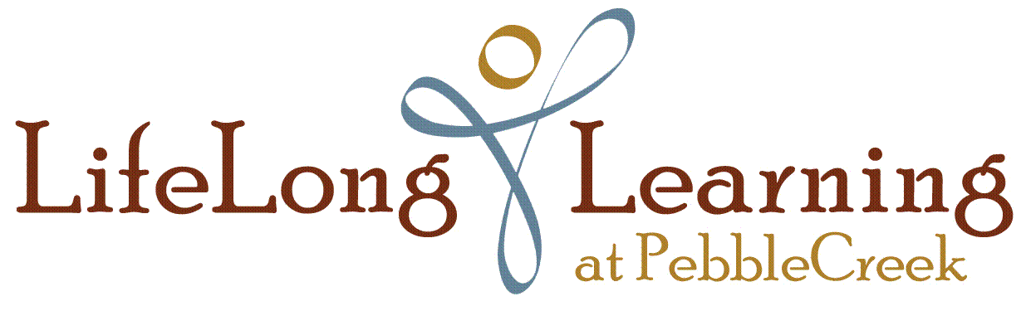

Non-Partisan Educational Programs Policy

LifeLong Learning at PebbleCreek (LLL) is a non-partisan, non-profit public charity (Section 501(c)(3), as determined by the Internal Revenue Service. Our primary mission is focused on adult educational activities.

LLL is prohibited from participation, directly or indirectly, in any political campaign supporting or opposing anyone for public office. LLL may not make campaign contributions to or for any candidate for public office. Likewise, officials of LLL may not make public statements on behalf of LLL in favor of or against an issue that functions as a political campaign intervention that implies support or opposition to a candidate for office. In the same vein, LLL may not participate in substantial legislative activity, commonly referred to as lobbying a legislature, in an effort to influence passage or defeat of legislation. Failure to comply with these restrictions may jeopardize LLL’s tax exemption status.

On the other hand, LLL may conduct educational programs on matters of public interest in a non-partisan manner. Nothing in this policy affects the right of an individual acting as such to express his or her own personal political views on any issue or to support or oppose any candidate for public office. Questions about this policy should be referred to ____ or to the LLL Compliance Director.

Approved by the LLL Board of Directors
January 17, 2019

